Designers’ Page

Every production is a collaboration involving many, many people. While CATCO has from the beginning been “an actors’ theatre,” the company has also focused when it could on improving the design elements of its productions. Over the last 7 years or so, since moving to the Riffe Center completely, CATCO has been able to enhance the technical design elements tremendously. Below are the “deep thoughts” of several of CATCO’s designers for this production of The Complete History of America (abridged).

Kate Robbins: Costume Designer

Part of the reason I have spent over 30 years as a theatre designer is the fact that every show is different; no two projects are ever alike. Even designing the same script multiple times is not boring because the production team, the design team and the cast are different each time. There is always a sense of anticipation, of excitement, as one begins each new project and, although there are some basic things I do for every project, such as read the script several times, each production requires a little bit different approach. I had seen CATCO's production of The Complete Works of Shakespeare (Abridged) and had thoroughly enjoyed it. So when TJ Gerckens, CATCO’s Production Manager, offered me the opportunity to design The Complete History of America (Abridged), I jumped at the chance.

For most projects, my design approach incorporates research of period style and the use of the design elements of line, mass, color, and texture to express character and assist in telling the story. This show, however, is more a revue than a classically constructed theatrical piece, which brings to the job unique demands and challenges. Although I did do research for this project, it was more for the purpose of facilitating conversation with the director and sharing ideas with the other members of the design team.

In approaching this production, one of my first considerations was the safety of the actors. The three actors play multiple characters and race back and forth at a breakneck pace in order to make costume changes. That being the case, the choice of shoes for them was extremely important. For Jon and Tod, it was essential that the shoes appear to be dress shoes, but they could not have hard soles, as they would be constantly slipping. My next consideration was the rapid pace of the show. It was a challenge to make sure that we had enough of a costume change to make the character transition clear to the audience, but not so much that it would slow the pace of the show. I also sought to realize the approach the director articulated - that the costume pieces should appear to be items the actors themselves could have located or created and assembled to tell the story.

In addition, since the actors get hit with everything from water to Bavarian crème pie, it was critical that the costumes be easy to maintain and be durable. Finally, I wanted the base costumes to express the individuality of each of the actors and the costume pieces to add to the sense of irreverence and silliness expressed in the script.

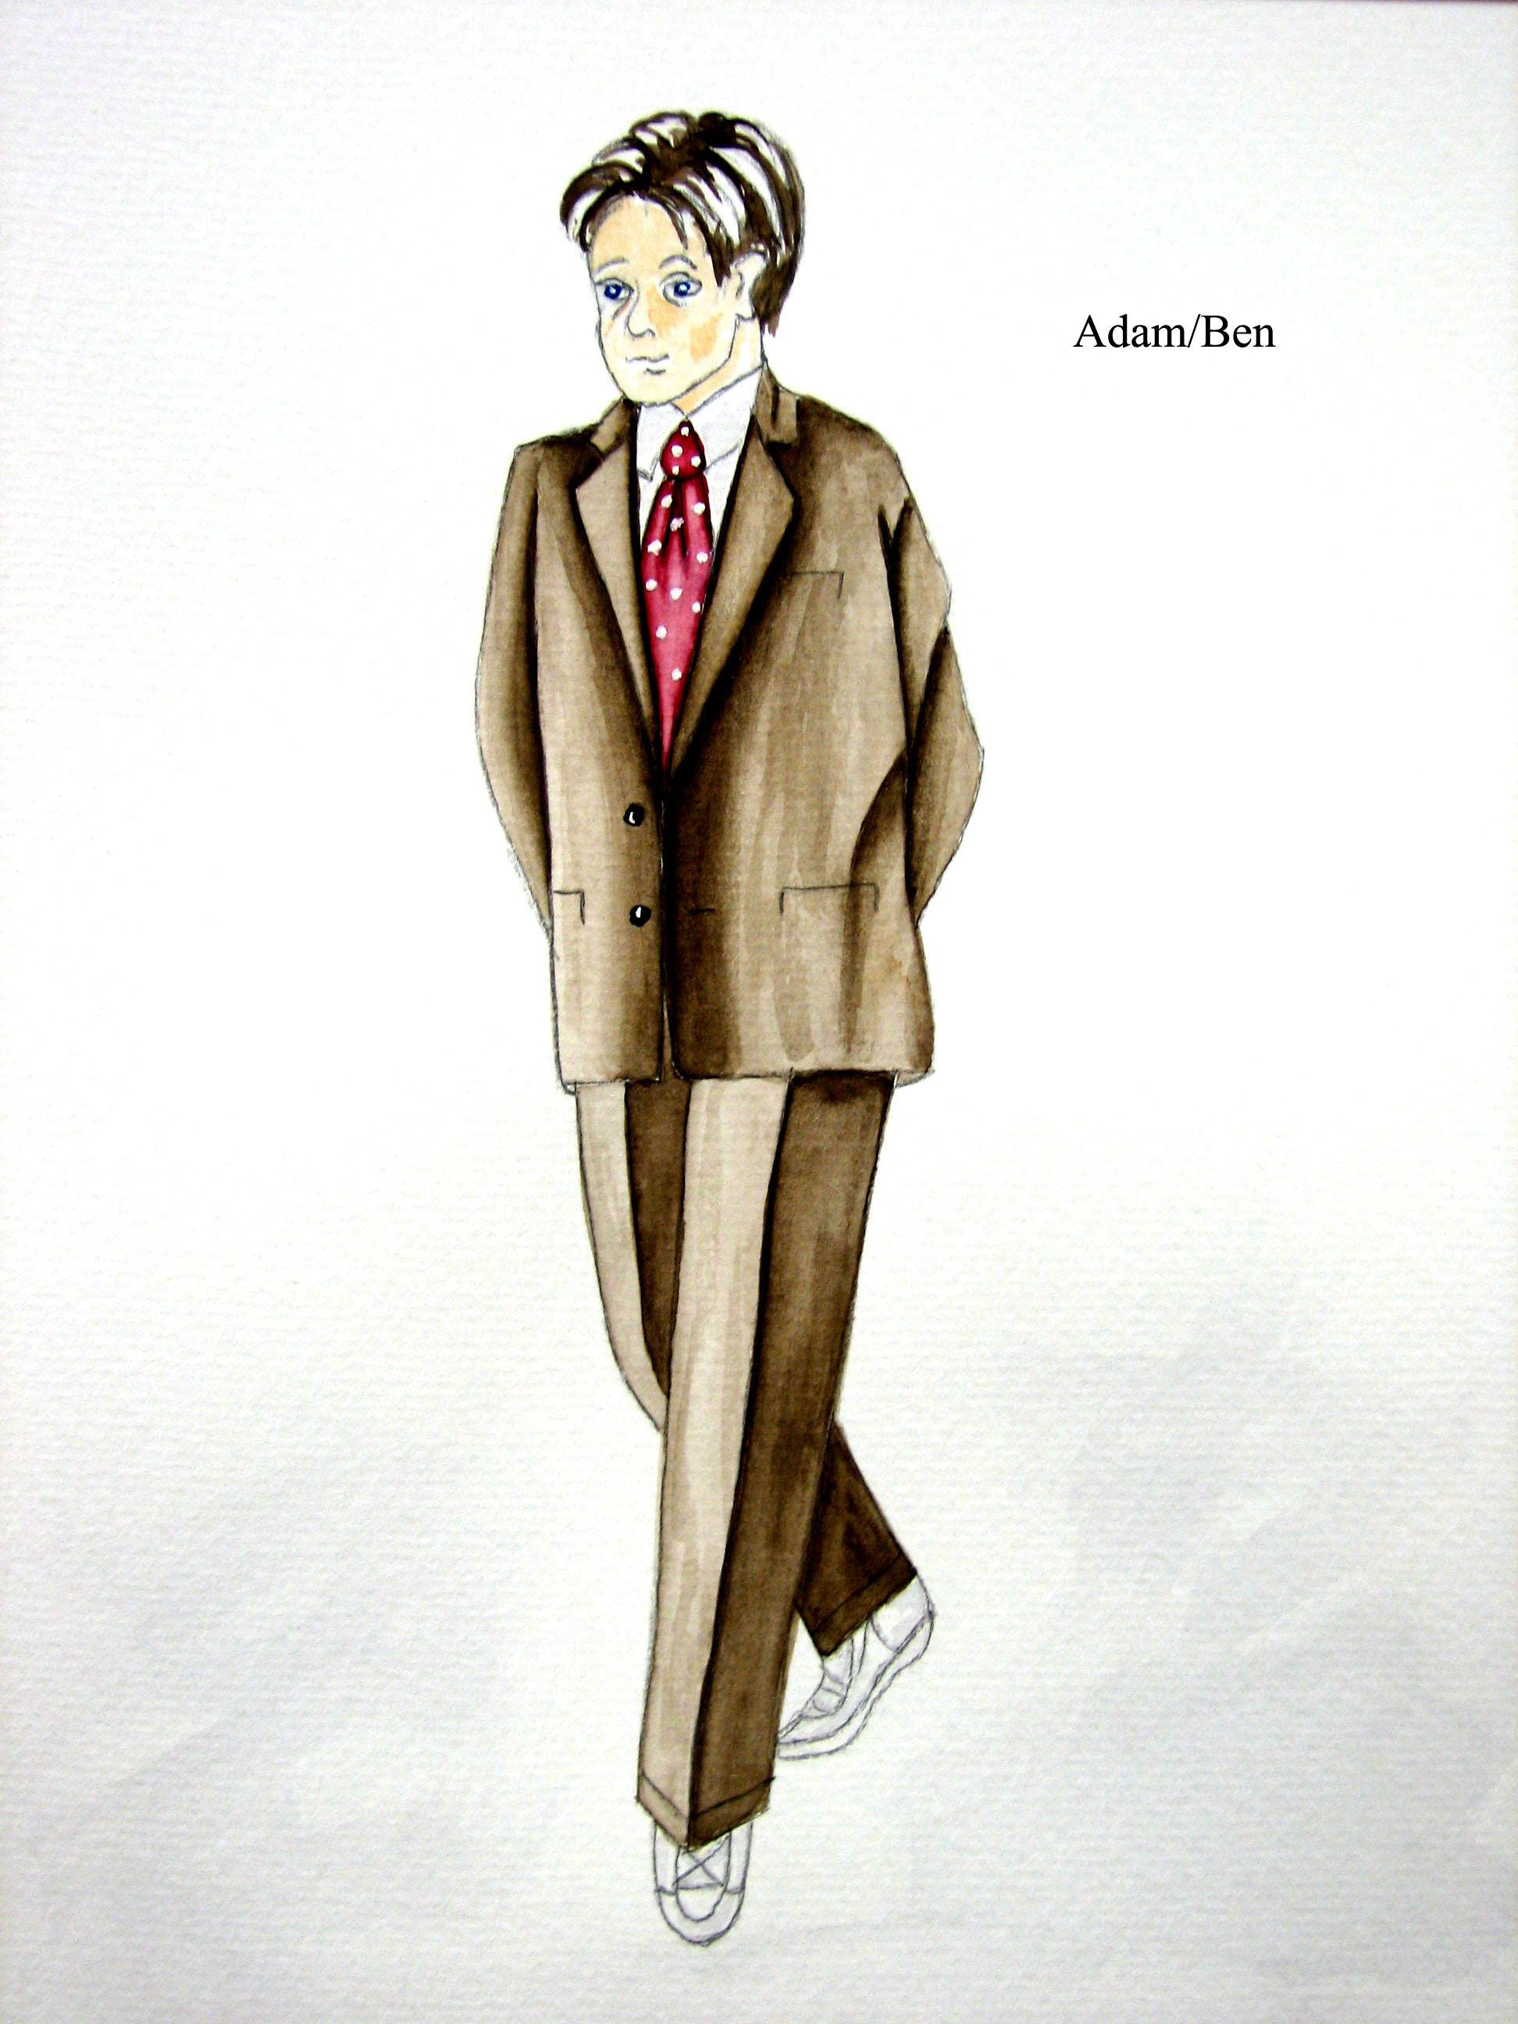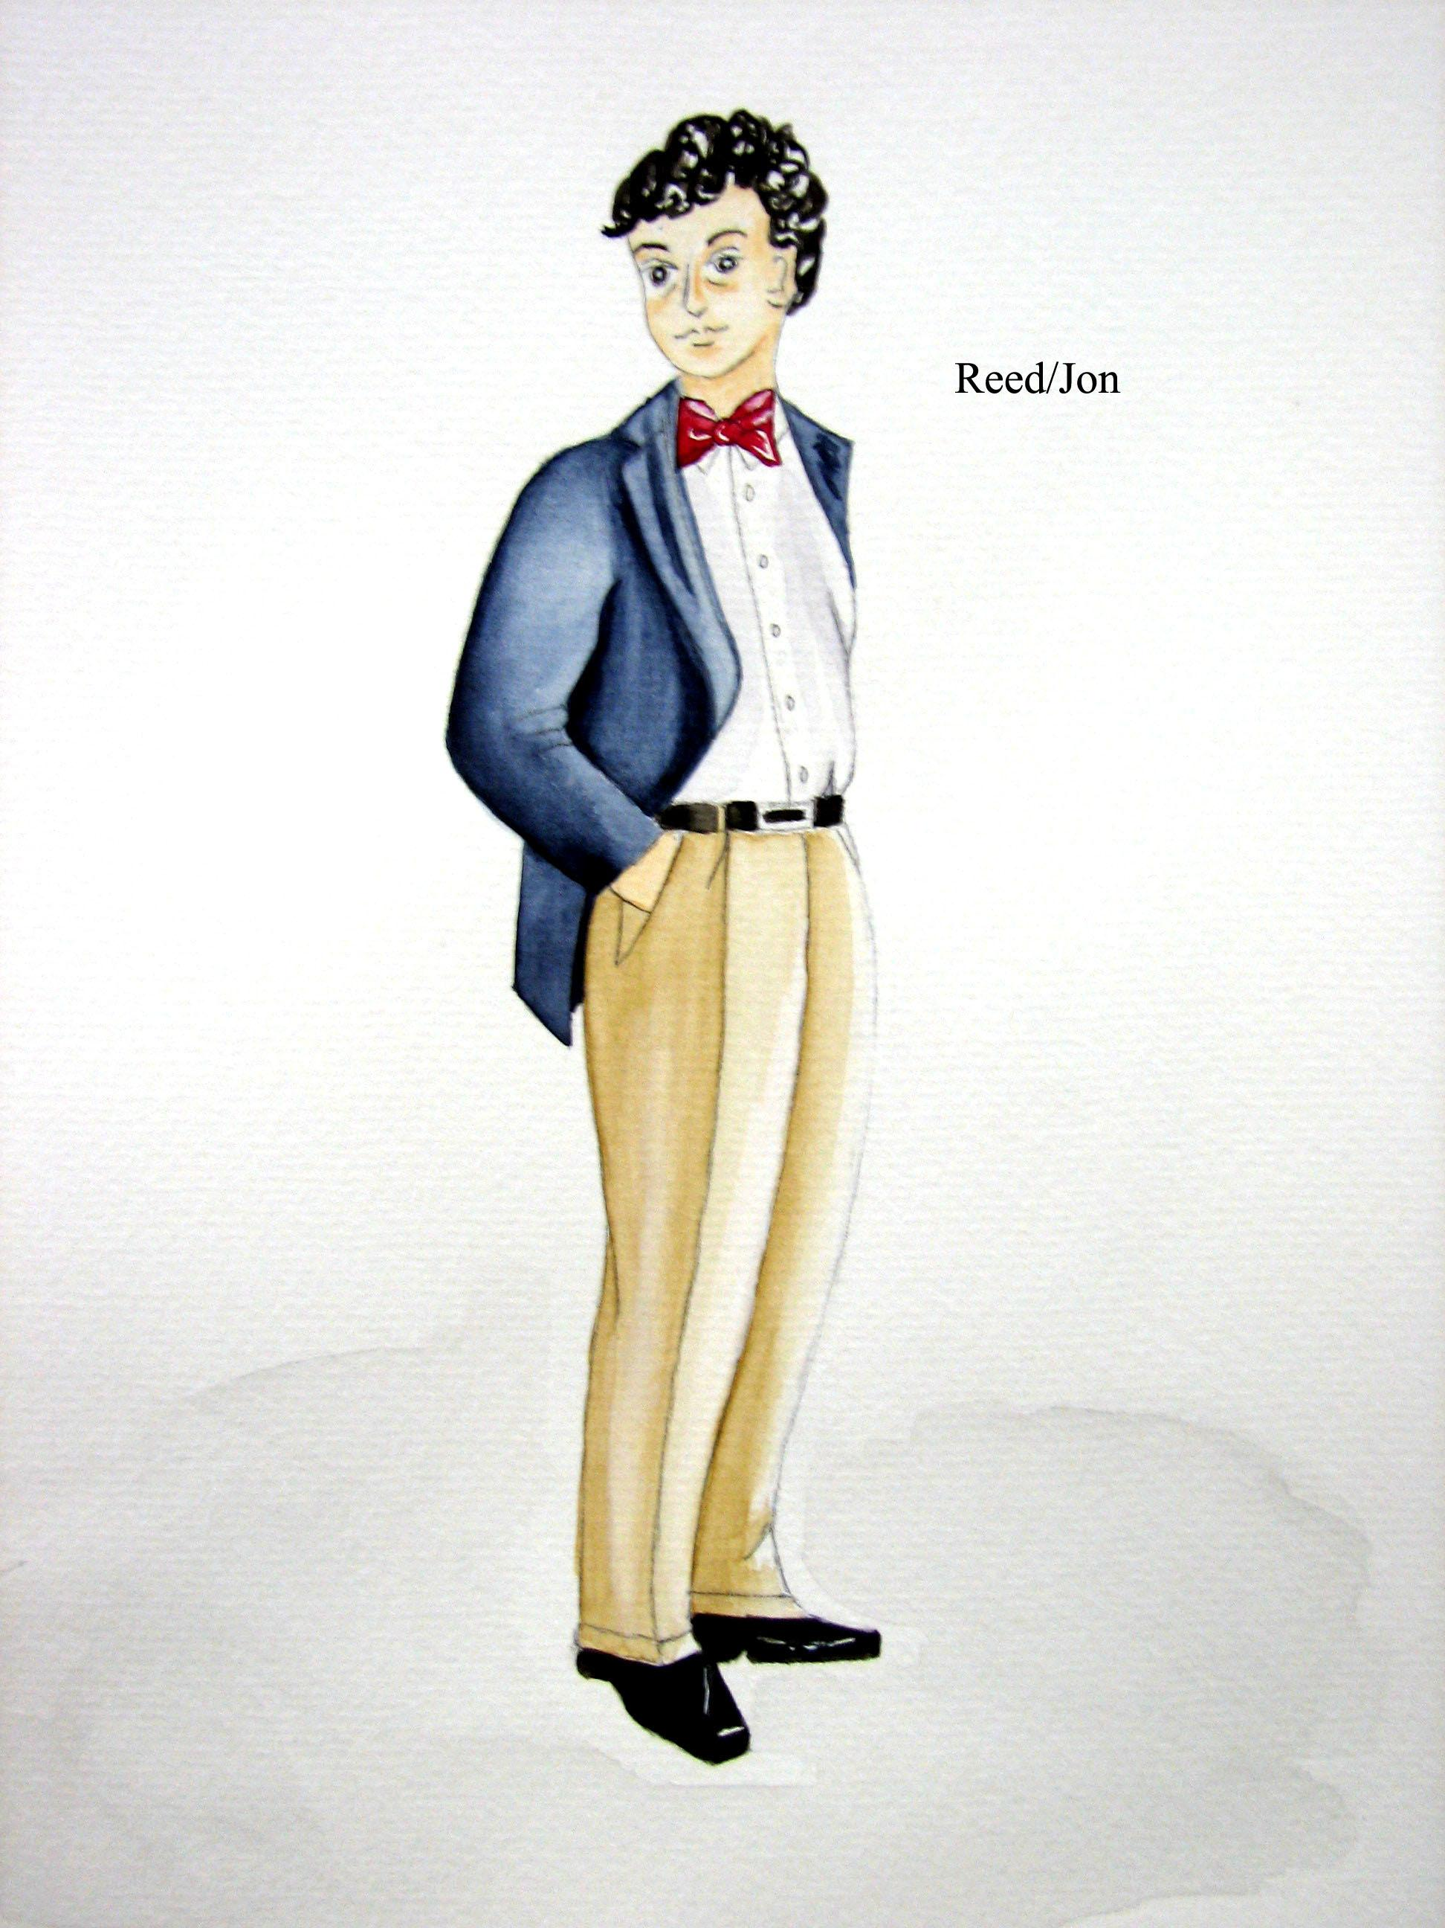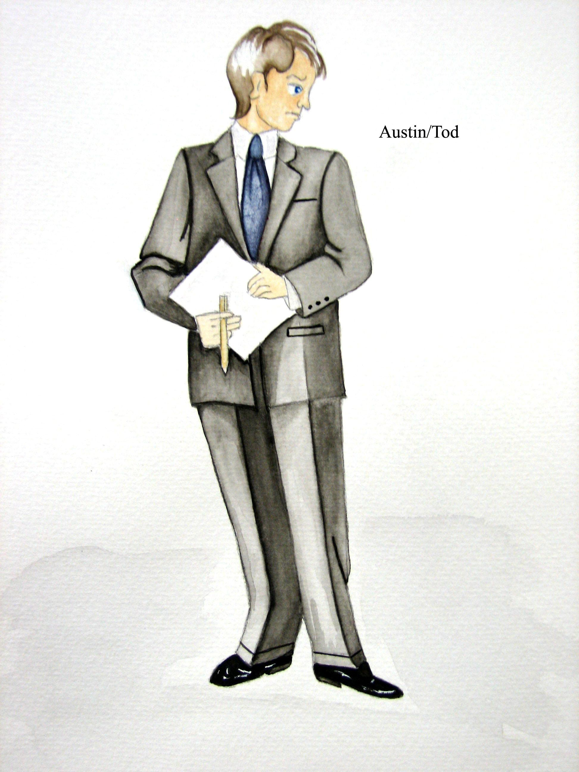

John Bohuslawsky: Lighting Designer

I've approached lighting this show in a way that allows me to stay open to whatever Geoff Nelson, the director, and the cast come up with. The nature of the play—it is a comedy—and the rehearsal/production schedule shaped this need for flexibility. Based on many readings of the script and a few discussions with the director and other participants, and having had some experience working with Geoff on this type of play in the past, I came up with a base plot which will allow me to cover all areas of the stage.

My base plot will allow me to cover every area of the stage with red, white and blue light (kinda patriotic don't you think?). In addition there are groups or systems of lights for specific tasks, monologues, and group scenes. Some lights are placed to illuminate (as well as affect) the scenery, some to help put the audience in a specific "place" (a foxhole, a radio show studio, a hallucination etc...), and some are quite literally dictated by the script (e.g., the slide show scene). I included "spares" in the plot for those unexpected moments that we'll find during the rehearsal process, especially the "cast run through" (a full-run of the play just before going into “tech week”). These "spares" are lights that I would like to attempt to use for specific moments. They may or may not work (based on new blocking or a change in the script because a joke was not working). If they work I'll say " hurray"; if not, there's a plan "B" and even a plan "C" for each of them.

I also have reserved a number of units for the truly unexpected moments—moments that will not come out until all components (set, costume, props, actors) of the play come together in the theatre. These reserves are for the accidental moments and the suddenly inspired moments. They are there because I know they will be used; at this moment in time, I do not know how, but we'll know by opening night.

Stephanie Gerckens: Scenic Designer
What fun it is to work on a variety of projects! Sometimes there are extremely time period specific set designs. Sometimes there are highly abstract environments. Occasionally there are plays with little set indicated so you bring to the drawing board your emotional reactions to the script. Then there is a play like this. Fun and speed seem to be the main needs of the set. Then putting the actors in an environment that looked patriotic or "American" seemed to be a place to begin.
I say begin because I always look at the script and come to early meetings with the director and design team with visual ideas. Then the set design evolves from there. We spoke at a meeting of having a Vaudeville feel to the set. Then later we found the opening of doors on the set walls could be funny and we took that concept further. The set was to stay simple and open so the actors could move on and off very easily. There are places to change costumes built into the design. The large shapes on walls are there to give a feeling of good old theatre days. The painting style is also reminiscent of Vaudeville era scene-painting techniques. I took the necessary red, white, and blue hues and muted them so they wouldn't be too visually jarring. All this work.... but I hope the silliness on stage is what gets the attention! It's a funny show!

Elizabeth Langford: Properties Master

The interesting thing about doing props for a show entitled “The Complete History of America” is how FEW actual historic pieces there are in this production. (That must be where the “abridged” part comes in!!!)

As Properties Master, my design concept always includes very extensive research into the period for historic accuracy. As is also the case with the Costumes and Set Designers, this is a given. However essentially all of the props for this show are directly related to Slapstick, Sight Gags and Clichés and have no “historic accuracy” and very little historic significance......except in Vaudeville perhaps, which does have a huge place in American History and in the American Theatre.

One of the big challenges of this show was more about stamina than anything else....how long the props would survive the actors before needing to be repaired or replaced. In this case, that is often!!

The Improvisational style of this piece also presented a challenge of its own in the constant state of change as rehearsals progressed. From the original Prop List that I came up with, after reading the script the first time until the final week of Technical/Dress Rehearsal and the first Preview Performance, (at which point everything was FINALLY set) many, MANY props were suggested, acquired, tried out and subsequently rejected.

The fun part of a show like this, though, was developing pieces and making them work. Such was the case of the Lincoln puppet and “gun.” Using suggestions from the original production helped, but in most cases it was just a matter of experimentation and physically “working it out.”

The Red-White & Blue patriotic theme made its way into my subconscious and everything acquired was either red or blue (providing that choice was available).

As with the Set, Lights and Costumes designers, our main objective is to enhance the production, blend in and bring the show to life, and by no means call attention to itself. I do hope this was achieved. It is truly a very funny show!!!!!

